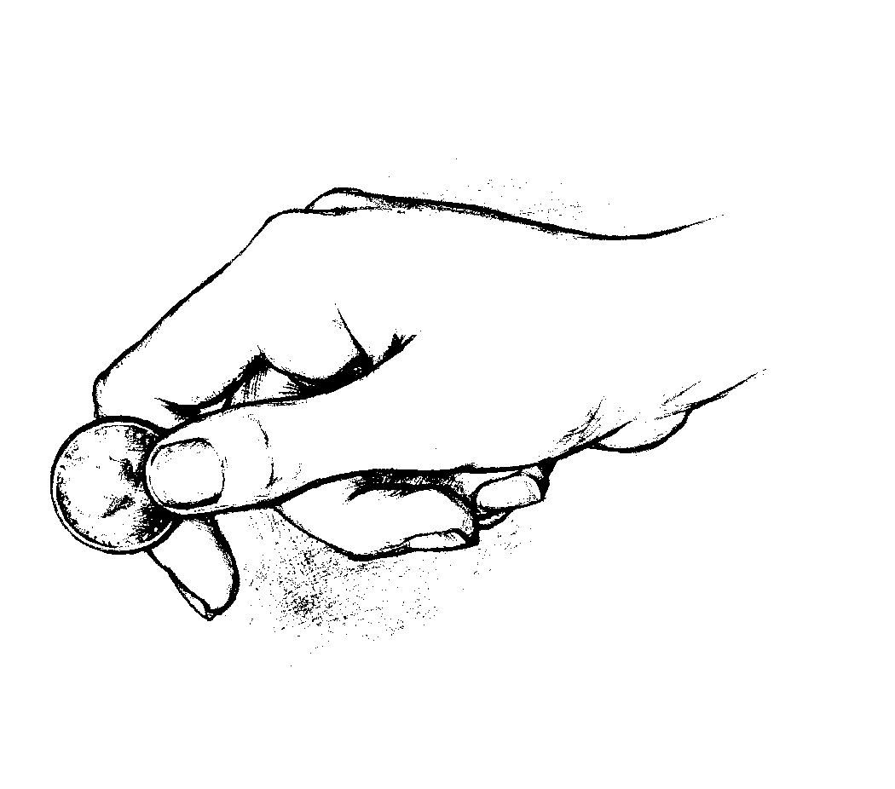
A _ _ _ _ _ of everything from the land… belongs to the _ _ _ _; it is holy to the Lord. Leviticus 27:30 _{NIV}

